Manual of Red2D

Xiang Li, Hokkaido University

<https://www.xiangli-lab.com/>

Red2D is a small package for Igor Pro to reduce 2D elastic scattering data to 1D I-q or I-2θ profiles. This package is suitable for light users who focus on simple data reduction, including time, transmittance correction, etc. For more comprehensive data reduction, I recommend using *Nika*, developed by Dr. Jan Ilavsky. I have confirmed the accuracy of reduced 1D profiles from Red2D by reducing the same 2D images with *Nika*.

*It will be nice if you would acknowledge me in your publications.*

*Example: The SAXS/WAXS/SANS data reduction was performed using a reduction package Red2D (*[*https://github.com/hurxl/Red2D*](https://github.com/hurxl/Red2D)*) on a data analysis software Igor Pro.*

# Requirements:

* Igor Pro 9.0 or later by Wave Metrics
* This package has been tested on macOS Big Sur and Windows 10.
* Red2D package 2.0.0 and newer cannot handle 1D data reduced with previous packages because I changed the naming rule of 1D waves to improve the compatibility with other software and packages, such as NIST model fits package and SasView.

# How to install

1. Download the package from GitHub and unzip the file.

<https://github.com/hurxl/Red2D/blob/master/README.md>

1. Move the unzipped folder into your local WaveMetrics folder.

e.g. ~/Documents/WaveMetrics/Igor Pro 9 User Files/Igor Procedures

1. Launch Igor Pro application, and you will see a “Red2D” tab.

# Common tips

1. Use “Data Browser” (Command + B) to organize your data.
2. Create different datafolders for different configurations (SDD, beam center, etc.).
3. Use “Set Current Datafolder” to make the target datafolder active. A red arrow will appear on the left of the datafolder when the folder is activated. Only the data (waves) stored in the active datafolder (with red arrow) will be processed.
4. You can close any graphs, tables, panels whenever you want.

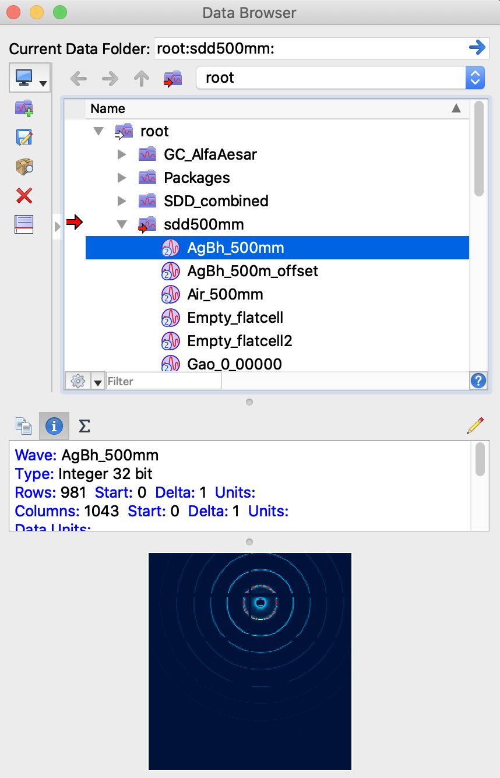

# How to use

## Load Images

Select one of the menus to load images.

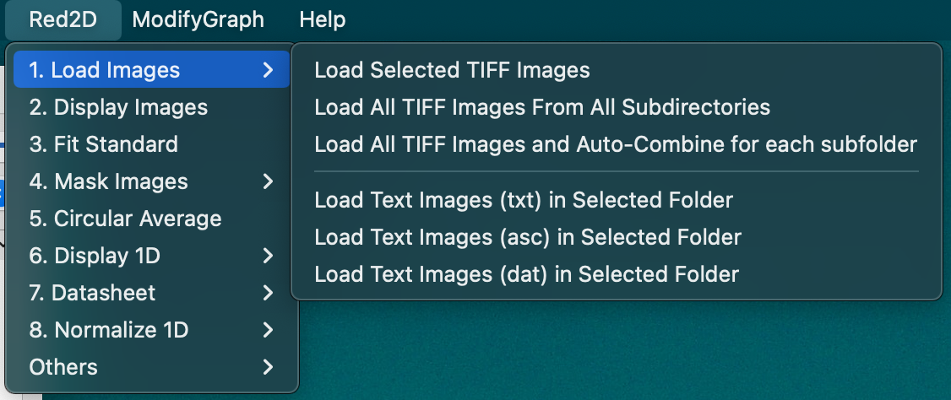

*Tips:*

* When loading images, the unpreferable characters for Igor Pro will be replaced with “_” or “X”.
* “Load All TIFF Images and Auto-Combine for each subfolder” is similar to “Load All Images From All Subdirectories” but it will add all images from the same subfolders to make one new image. This feature is useful when you take a series of images and want to add them together.

## Display Images

1. Set your current datafolder (the datafolder with an arrow) where your images exist.
2. Then click “Display Images” and you will see following panels.
3. Click the image name to change the image on graph.

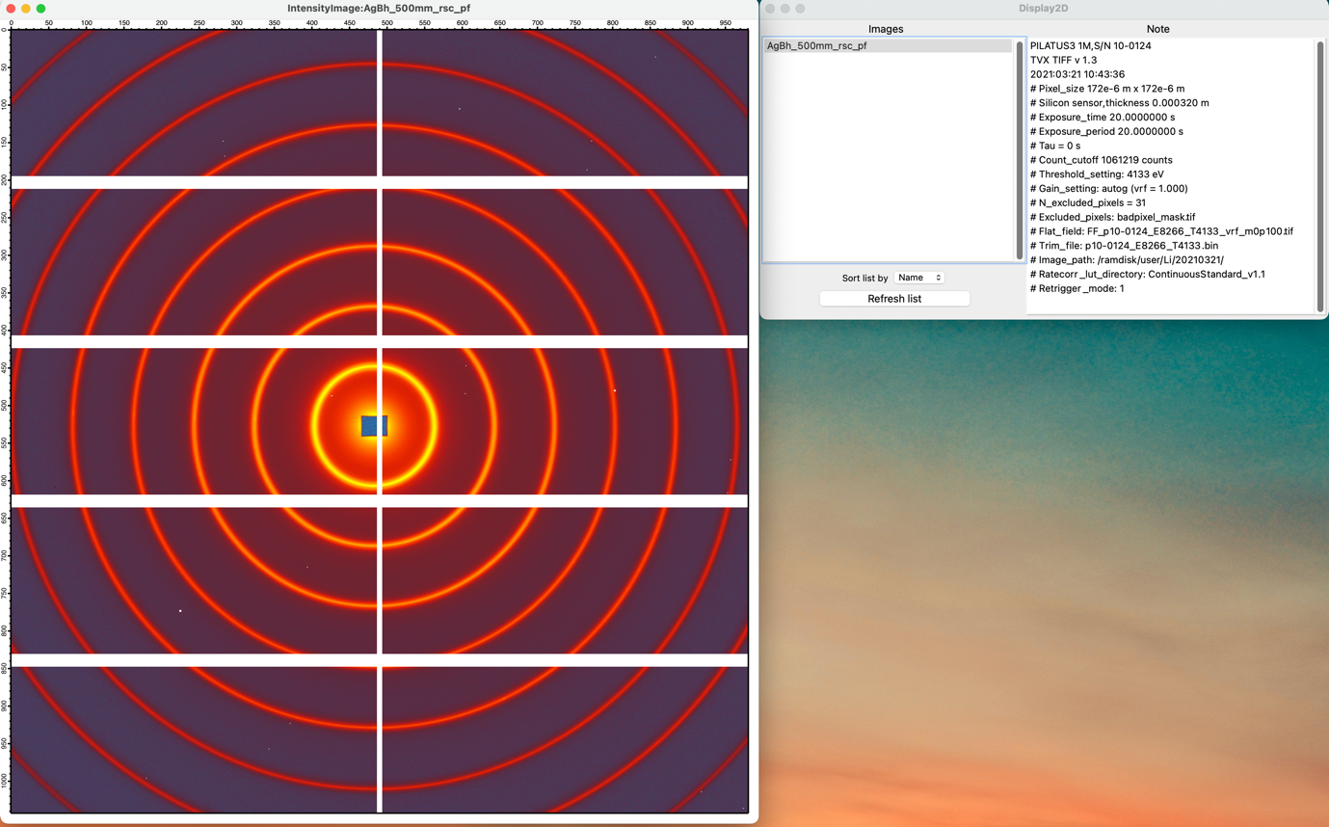

*Tips:*

* If something wrong, try to click “refresh list” button.
* **Do not mix up non-image waves in datafolder where the images exist.**
* **All image waves must have the same image size.**

## Fit a standard to get beam center and sample to detector distance

1. Use “Display Images” to show the standards sample you want to fit, and then click “Fit Standards”.
2. In the Fit_Q_Standards panel, select one of the standards that this package supports.
3. Type following information:

* *Beam center (X0, Y0)
* *Sample to detector distance (SDD)
* Detector tilt angle (Tilt_X, Tilt_Y) (Leave them zero if your detector is not tilted.)
* Wavelength (Lambda)
* Detector pixel size (Pixel size)
* Index of first ring to fit (First ring to fit)
* Index of the last ring you to fit (Last ring to fit)
* Background intensity to mask (Background Int)

* They are fit parameters. So, giving your best guess is enough.

1. A semi-transparent mask will appear on the image. Adjust your initial guess for beam center and SDD to make the mask transparent rings covers the peaks of your standard. You can also change the width of the ring with “Ring width”.
2. Click “Get Points on Rings” to find the peak positions of your standard sample. If the points are not on the scattering peak rings, try to change the background intensity, then click “Get Points on Rings” again. You can also try to check/uncheck Vscan (vertical peak scan) and Hscan (horizontal peak scan) to improve accuracy.
3. Click “Fit Rings” to perform the fit. The fit result will be automatically stored and used in the following data reduction. The result also appears in the command window of Igor Pro (Command + J).

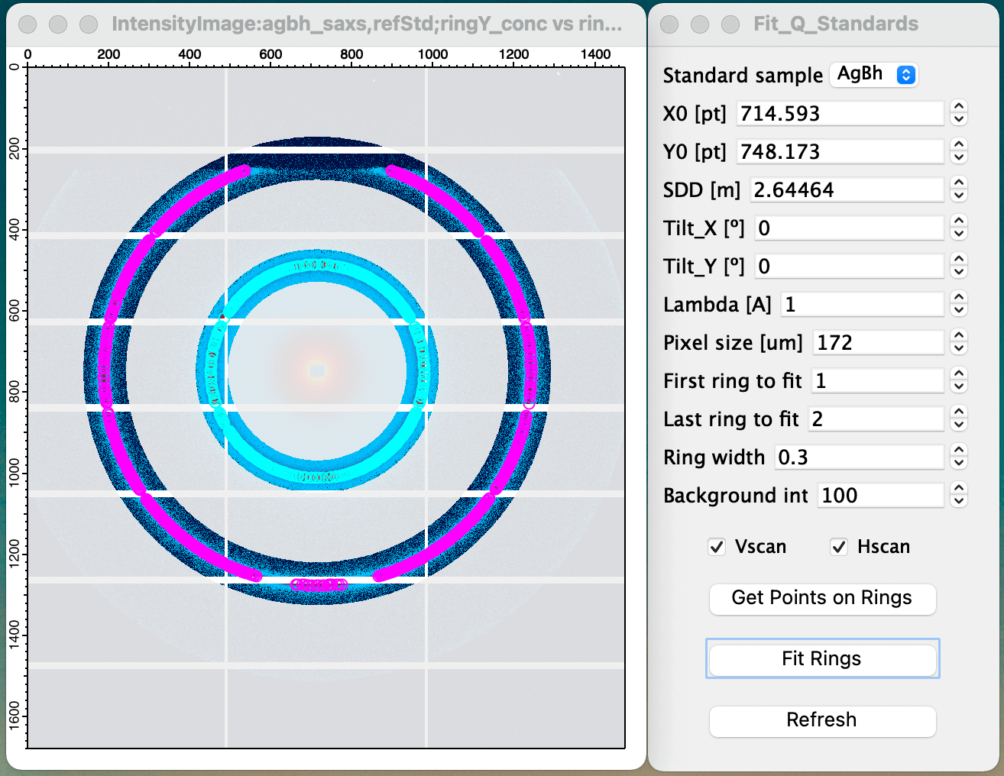 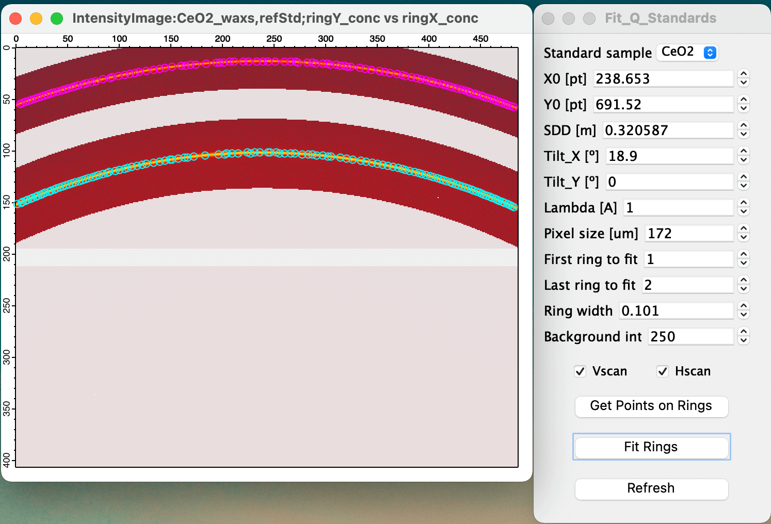

*Tips:*

* Use tilt-X and tilt-Y to correct tilt angles of the detector plane if your detector is tilted. I use right-hand coordinates, and right-handed screws rule for tilt direction. See the illustration below. The red arrows show the positive tilt angle.

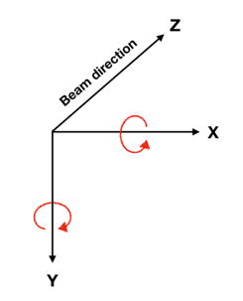

## Create masks

1. Use “Display Images” to show a scattering image, then click “Make Masks” to show the Mask Panel.
2. Sector mask:
   1. Type the beam center X0, Y0 (may be auto filled)
   2. Type center angle (φ0) and spreading angle (Δφ) of the sector mask
   3. Click “New Sector Mask” to create mask
   4. Use “Save As” to save the sector mask with user-defined name
3. ROI mask:
   1. Follow the instruction on the Mask Panel to draw ROI (region of interest).
   2. Click “New ROI Mask” to create mask (Tips: Use Reverse ROI to mask region outside the ROI)
   3. Use “Save As” to save ROI mask with the user-defined name
4. Misc.
   1. Masks will be saved in a datafolder, “*your image datafolder*:Red2DPackage:Mask:”.
   2. Saved masks are shown in the list box. You can append or remove masks from the scattering image by click the mask names.
   3. You can merge multiple masks to one mask by using “Merge Masks”. Only selected masks will be merged.
   4. You can delete masks.

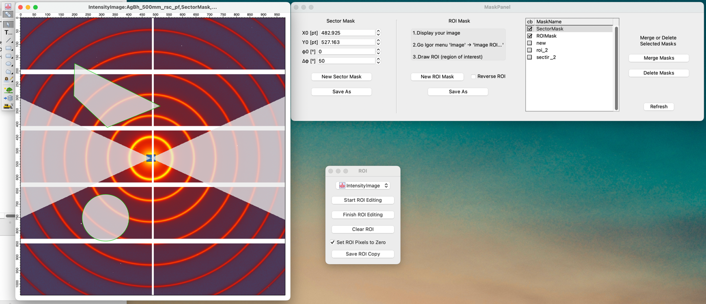

*Tips:*

* Spaces between detector panels will be automatically masked when these pixels contain negative values or NaN. You do not have to make and apply masks.

## Circular Average

1. Type all parameters (may be auto filled)
2. Set mask
3. Click “Circular Average”, and a new datafolder, “Iq1D…” will be generated, containing the reduced 1D data.

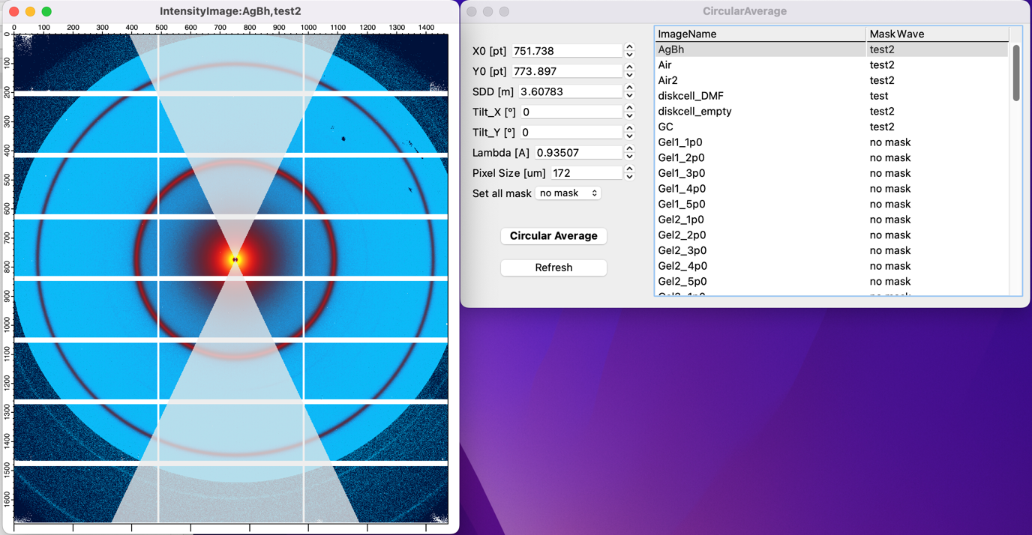

*Tips:*

* Reduced 1D data follows the name rule of the NIST data analysis package (NCNR_SANS_package:<https://www.ncnr.nist.gov/programs/sans/data/red_anal.html>). You can use the NIST package to perform basic model fits on your 1D data.
* Negative and NaN pixels will be automatically removed. You do not need to make a mask for panel spaces if the values at these pixels are negative or NaN values.
* Solid angle correction is performed based on B. R. Pauw, Everything SAXS: small-angle scattering pattern collection and correction. J Phys Condens Matter. 25, 383201 (2013).
* If something wrong, click refresh.
* You can click ImageName to change the image to show on graph.
* You can click MaskWave to change mask to be applied to the corresponding image.
* Set all mask will change the mask for all images.

## Click Display 1D and append 1D to show 1D data in a graph.

1. Set the datafolder to where the 1D data exist.
2. Click display or append 1D.

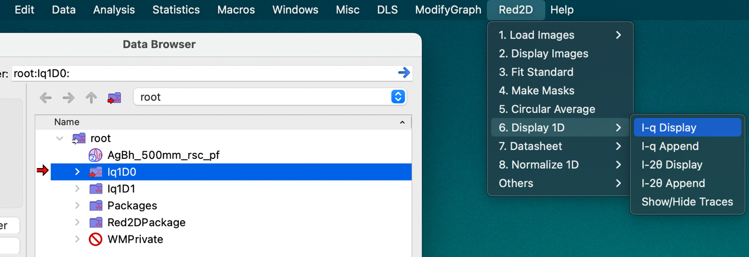



*Tips:*

* “Show Hide Traces” is a handy tool to show and hide traces on a graph.

## Create or Import a Datasheet

1. The datasheet is used to normalize 1D profiles or 2D images.
2. You can manually create and fill a datasheet in Igor Pro or import a prefilled datasheet from an excel sheet.
3. “Trans,” “Time_s” and “Thick_cm” **must** be filled; if you want to skip these normalizations for a sample, type “1” in these cells.
4. When you loaded and reduced new images, you can use “Append New Waves” to append them to the datasheet.

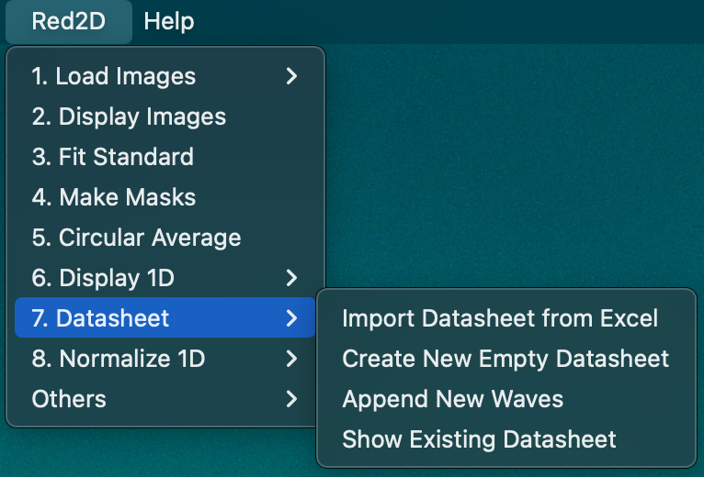

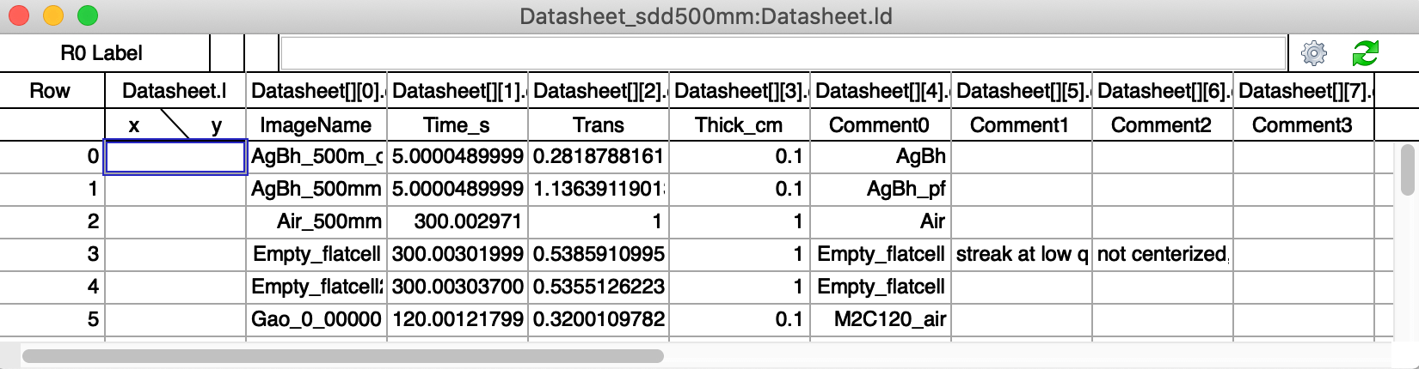

*Tips:*

* Regarding “Import Datasheet from Excel”
  1. A template excel sheet is included in the zip folder that you downloaded.
  2. The first row in the excel sheet is the header. Only the header named with “ImageName”, “Time_s”, “Trans”, “Thick_cm”, and “Comment0-3” will be imported.
  3. ImageName is the name of the images that you loaded in the beginning.
  4. The ImageName with unpreferable characters will be automatically replaced with underscore. For the ImageName starts with a number, a “X” will be appended in the beginning of the name.

## Normalize 1D data

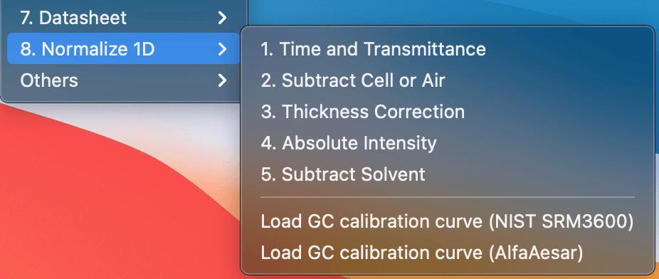

1. After the datasheet is correctly filled, you can normalize your 1D data by using “1. Time and Transmittance”, “2. Subtract Cell or Air.”, …
2. I recommend you normalize your data following the order in the menu unless you truly understand what you are doing. See appendix for the normalization procedure.
3. Notes for absolute intensity correction:
4. Load calibration curve of glassy carbon
5. Calculate a ratio of [your data]/[Calibration curve]
6. Click “Absolute Intensity” and type the intensity ratio to perform the correction.

# Misc

You can find several useful tools in “Misc.”

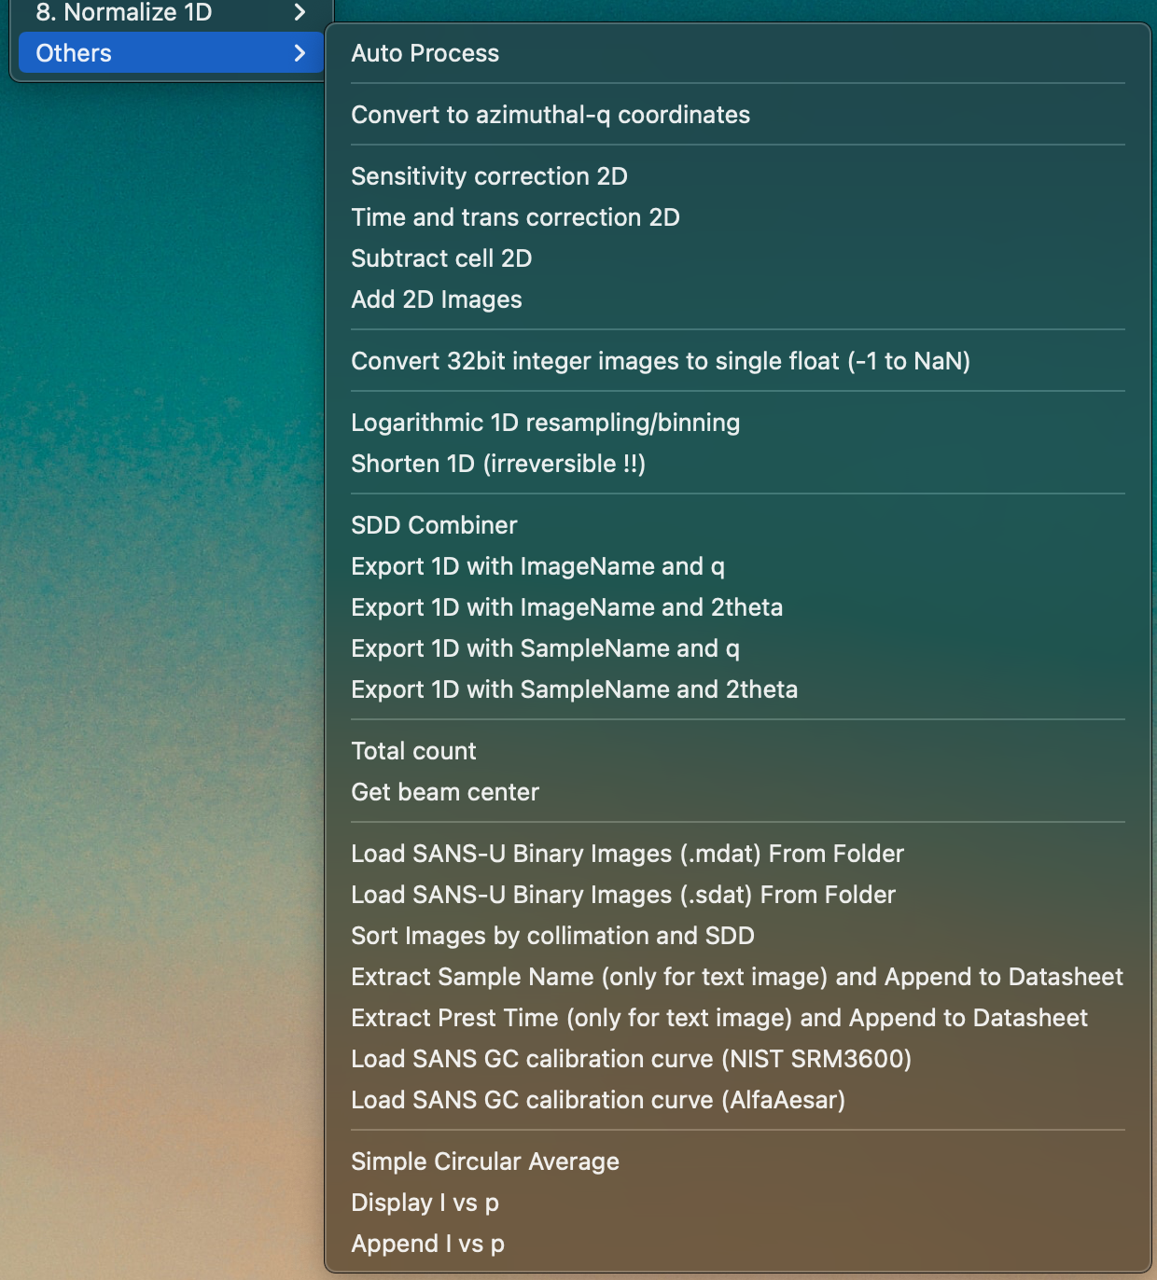

## Auto Process

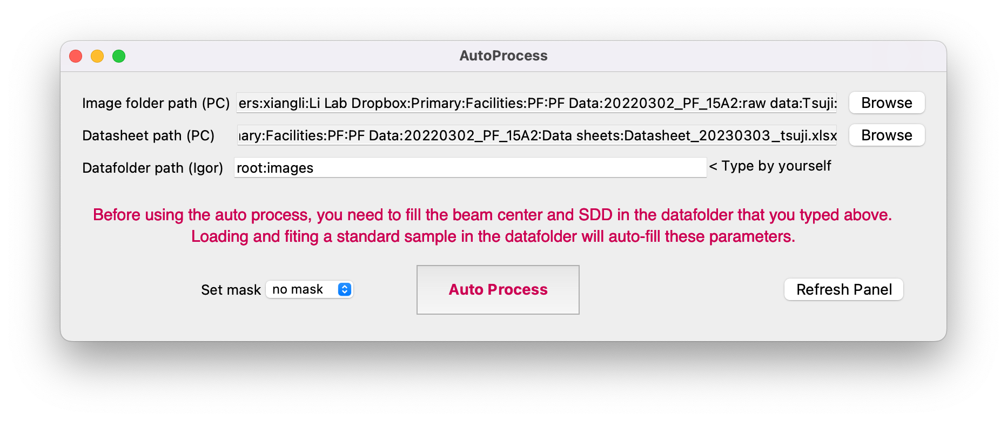

When you preces the auto process button, this procedure will automatically load and reduce images in the selected path. In addition, it will also automatically load datasheet from the selected path and perform the time and transmittance correction.

The auto process works as:

1. Load images from a predefined folder in PC.
2. Load datasheet from a predefined excel file in PC.
3. Import images to a predefined datafolder in Igor.
4. Copy **non-reduced** images to a working datafolder.
5. Then, circular averaging the images and normalizing the 1D profiles with the datasheet. Only for time and transmittance.
6. Copy the newly reduced images to a 1D datafolder nested in the predefined datafolder.
7. Delete the working datafolder.

## Convert 32bit integer images to single float (-1 to NaN)

This command converts 32-bit signed integer images to single float images in the selected datafolder. The masked pixel in 32-bit integer images, usually noted with -1, will be replaced to NaN during this process. This command is designed to maintain backward compatibility of Igor files created using old Red2D packages before v2.1.0. You do not have to run this command if you load the images using Red2D v2.1.0 or more recent.

## Convert to azimuthal-q coordinates

You can convert standard X-Y Images to azimuthal degree vs. q images, as shown below. The vertical axis shows the azimuthal degree, and the horizontal axis is q.

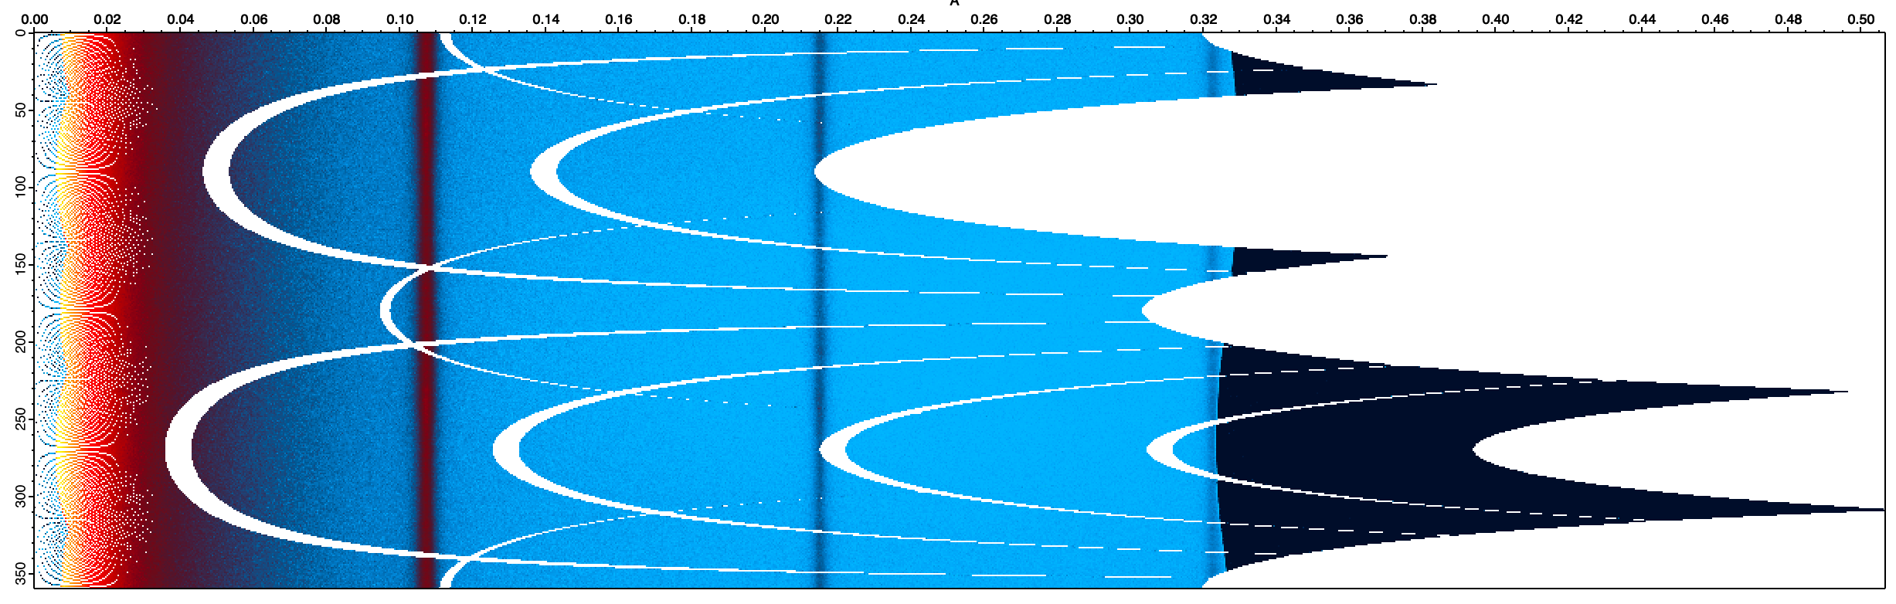

## Time and trans correction 2D

Perform the time and transmittance correction for 2D images. You have to load or create a datasheet using the functions located in the menu “1D normalization”.

## Subtract an Image

Subtract cell or any background for 2D images. You have to load or create a datasheet using the functions located in the menu “1D normalization”.

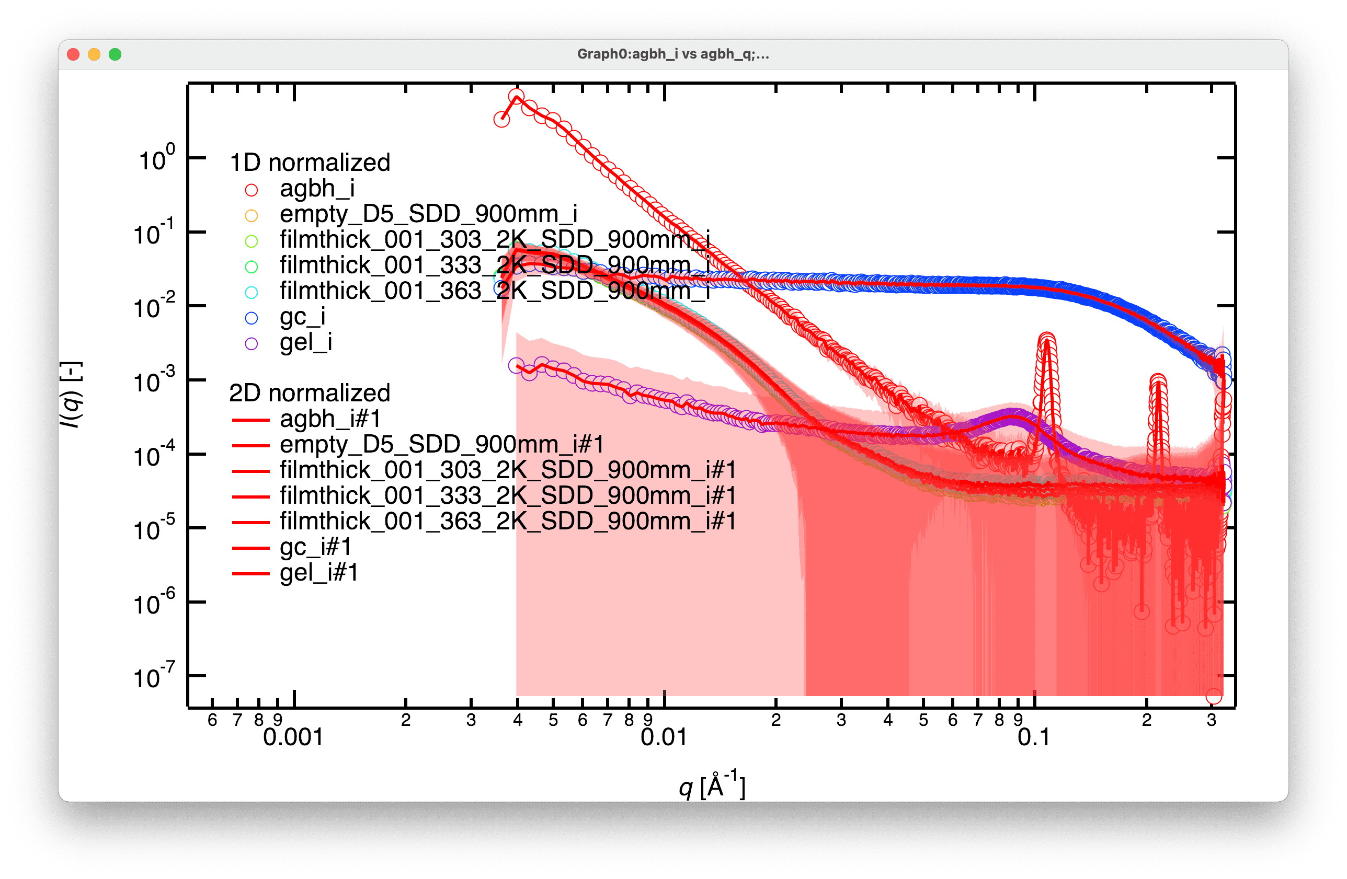

[Error report] The intensity was calculated correctly, but something wrong in the error calculation (2021-01-14).

## Add 2D Images

You can add multiple images into one image by using “Add 2D images”.

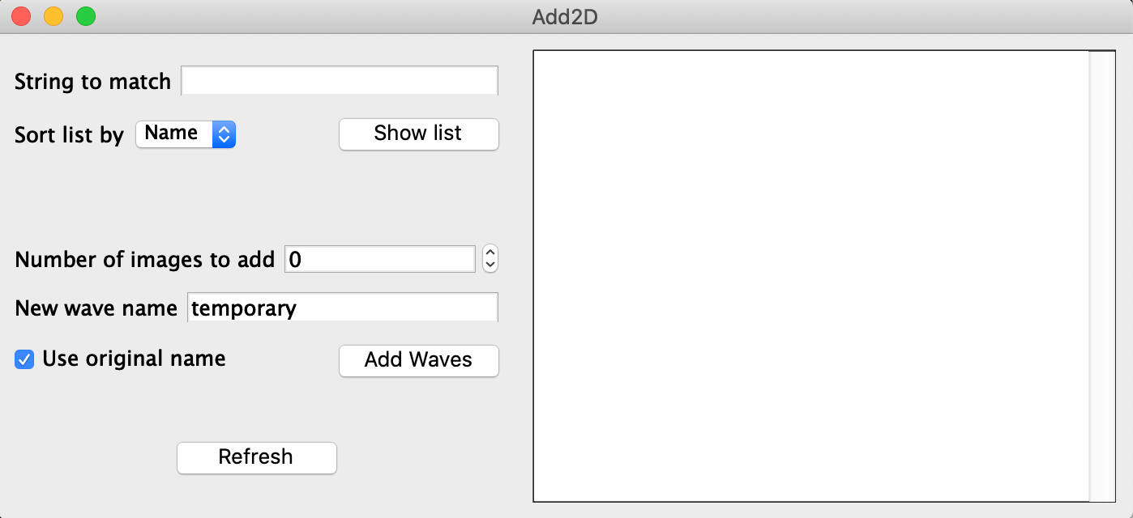

1. String to match: the common part of the image names. Use an asterisk (*) as a wildcard, e.g., use “*abc*” to get “testabctest”, use “*” to get all images.
2. Select a sort by list option, then click show list.
3. Numbers of images to add: the number of images to add together. e.g., If you have ten images and “Numbers to Combine” = 2, then five added images will be generated.
4. “New wave name” is a new name for the output image. When multiple images are generated, a sequential number will be added at the end of the names.
5. When “use the original name” is selected, the 1st name in each group will be used as the new image name. The name in the “New wave name“ will be overwritten.
6. Data will be saved in a datafolder “Added.”

## Logarithmic 1D resampling or binning

Resample or bin your 1D data on a logarithmic scale. You can change the base value to tune the interval of resampling or the size of a bin.

## Shorten all 1D in current datafolder

You can delete unnecessary points from your reduced 1D waves. Note that this process is irreversible. You may want to save your original 1D data somewhere.

## Combine 1D from different SDD

You can combine 1D data measured at different SDDs into a combined wave.

## Export 1D with ImageName

## Export 1D with SampleName

Export reduced 1D data in the current datafolder as general text files.

## Total count

Calculate the total count in each image in the selected datafolder. The result is currently stored in the corresponding Red2Dpackage.

## Simple Circular Average

Perform simple circular average of 2D images without any corrections. The pixels will be treated as just pixels, not be transformed to scattering vector. Useful to reduce 2D intensity-q map.

## SANS-U packages

Designed to reduce data from SANS-U, a small angle neutron scattering instrument, located in JRR3, Japan.

# Appendix

## Red2Dpackage folder

This datafolder will be automatically created in a directory where your images are stored. This datafolder stores global values, strings, and waves used in background processes. You can find stored parameters, such as beam center position, SDD, wavelength, pixel size, Image size, etc.

## Screenshots of step-by-step data normalization

**Raw**



*In the above graph, the intensity is displayed per pixel. In the latest version, the intensity is shown per solid angle.

**Time and transmittance corrected**



* The incident beam intensities of two distinct SDD overlap because the intensity is displayed per pixel. In the latest version, the intensity is shown per solid angle, and the incident beam intensities do not overlap for different SDDs.

**Air(Direct beam) subtracted**



**Cell subtracted**



**Sample thickness corrected**



**Absolute intensity corrected, using glassy carbon**



## Peak position of standards

$$q=\frac{2π}{d}, q=\frac{4π}{λ}\sin\left(\frac{θ}{2}\right) or in θ=2θ' q=\frac{4π}{λ}\sin\left(θ^{'}\right)$$

**Table. Silver behenate**

|  |  |  |
| --- | --- | --- |
| Peak number | d-spacing [Å] | q [Å−1] |
| 1 | 58.38 | 0.10762565 |
| 2 | 29.19 | 0.2152513 |
| 3 | 19.46 | 0.32287694 |
| 4 | 14.595 | 0.43050259 |
| 5 | 11.676 | 0.53812824 |
| 6 | 9.73 | 0.64575389 |
| 7 | 8.34 | 0.75337953 |
| 8 | 7.2975 | 0.86100518 |
| 9 | 6.48666667 | 0.96863083 |
| 10 | 5.838 | 1.07625648 |
| 11 | 5.30727273 | 1.18388212 |
| 12 | 4.865 | 1.29150777 |
| Doublet |  | 1.369 |
| Doublet |  | 1.387 |
| 13 | 4.49076923 | 1.39913342 |

Silver behenate d-spacing of (001) 58.38Å from Huang, T. C.; Toraya, H.; Blanton, T. N.; Wu, Y. X-Ray Powder Diffraction Analysis of Silver Behenate, a Possible Low-Angle Diffraction Standard. J Appl Crystallogr 1993, 26, 180–184

**Table. Si**

|  |  |  |
| --- | --- | --- |
| PEAK number | 2θ’ (λ 1.5405Å) | q [Å−1] |
| 1 | 28.441 | 2.00376238 |
| 2 | 47.301 | 3.27217002 |
| 3 | 56.12 | 3.83694455 |
| 4 | 69.127 | 4.62753269 |
| 5 | 76.373 | 5.04274818 |
| 6 | 88.026 | 5.66754871 |
| 7 | 94.947 | 6.01130427 |
| 8 | 106.702 | 6.54429257 |
| 9 | 114.085 | 6.84419552 |
| 10 | 127.535 | 7.31674949 |
| 11 | 136.882 | 7.5861853 |

## Basic knowledge

1. The error of intensity at each pixel is calculated based on Poisson probability distribution (e = I^0.5) and then averaged for multiple pixels with the same q value using error propagation equations (e = (e1^2 + e2^2 +…)^0.5/number of pixels = (I1 + I2 +…)^0.5/number of pixels). The error propagation is also used in normalizing 1D data.
2. The normalization of 1D data is performed based on the equations below.

$$\frac{dΣ}{dΩ}{\left(q\right)}_{sample}=\left(\frac{I{\left(q\right)}_{sample\&cell}}{Time⋅Trans}-\frac{I{\left(q\right)}_{cell}}{Time⋅Trans}\right)⋅\frac{1}{Sample thickness}⋅\frac{1}{Instrumentation factor}$$

$$\frac{dΣ}{dΩ}{\left(q\right)}_{sample}=ϕ\frac{dΣ}{dΩ}{\left(q\right)}_{polymer}+(1-ϕ)\frac{dΣ}{dΩ}{\left(q\right)}_{solvent}$$

Instrumentation factor refers to beam size, incident beam flux, detector sensitivity, etc.. Instrumentation factor is irrelevant to sample and can be corrected by using a standard sample, e.g. glassy carbon.

## Issues on circular averaging 2D scattering images having qx,qy coordinates

Red2D allows you to convert and display 2D scattering images on qx, qy coordinates. However, this conversion will neglect qz elements in the q vector, causing an inaccurate estimation for the q scalar values, especially for large q values. This effect can be visualized by taking circular average of a 2D image in pixel coordinates and a converted 2D image in qx, qy coordinates (See figure below).

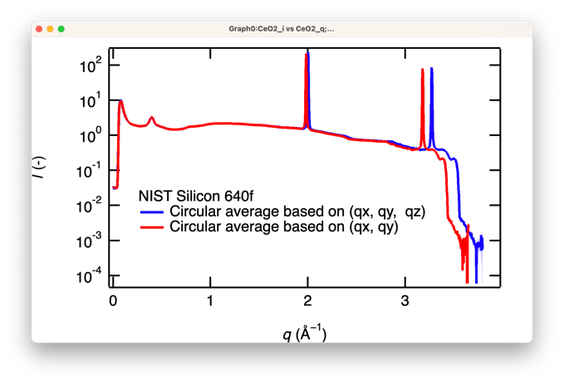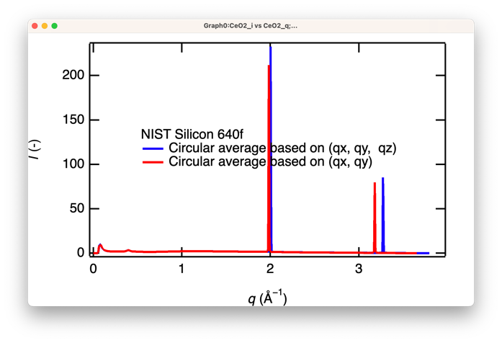

Figure. WAXS Profiles of Silicon crystal powder (NIST Silicon 640f). Left: semilog-plot. Right: Linear-plot.

The Bragg peaks from Si crystal from the qx qy image shifted to small q values and the extent of shift is more apparent in large q values.

In addition, the peak intensity from qx, qy image slightly decreased. As the intensity in the non-peak region were almost the same, the changes in the peak intensity is likely because of the qx,qy rounding process.

In conclusion, I do not recommend obtaining the 1D I-q profiles using the qx, qy converted scattering images.